java.util.Collection is the root interface in the hierarchy of Java Collection framework in java.
There are two groups of interfaces related to collections: Collection and Map.
Map interface is a member of the Java Collections Framework, but it does not inherit Collection interface in java.
Collection inherits Iterable interface.
Maps doesn’t inherit iterable intreface.

Collection- List, Set, Queue,
List- ArrayList, LinkedList, Vector, Stack,
Set- EnumSet, HashSet, LinkedHashSet, TreeSet,
SortedSet- TreeSet,
NavigableSet- TreeSet,
Queue- LinkedList, PriorityQueue
Deque- ArrayDeque, LinkedList
Map- HashMap, TreeMap, HashTable, EnumMap, IdentitiHashMap, LinkedHashMap, Properties, WeakHashMap,
SortedMap- TreeMap,
NavigableMap- TreeMap,
BlockingQueue (Concurrent Queue Implementation)- LinkedBlockingQueue, ArrayBlockingQueue, PriorityBlockingQueue, DelayQueue, SynchronousQueue,
ConcurrentMap- ConcurrentHashMap (concurrent analog of HashMap, an alternative of HashTable),
ConcurrentNavigableMap- ConcurrentSkipListMap (concurrent analog of TreeMap),
ConcurrentNavigableSet- ConcurrentSkipListSet (concurrent analog of Treeset),

Core classes and interfaces in java.util.List hierarchy:
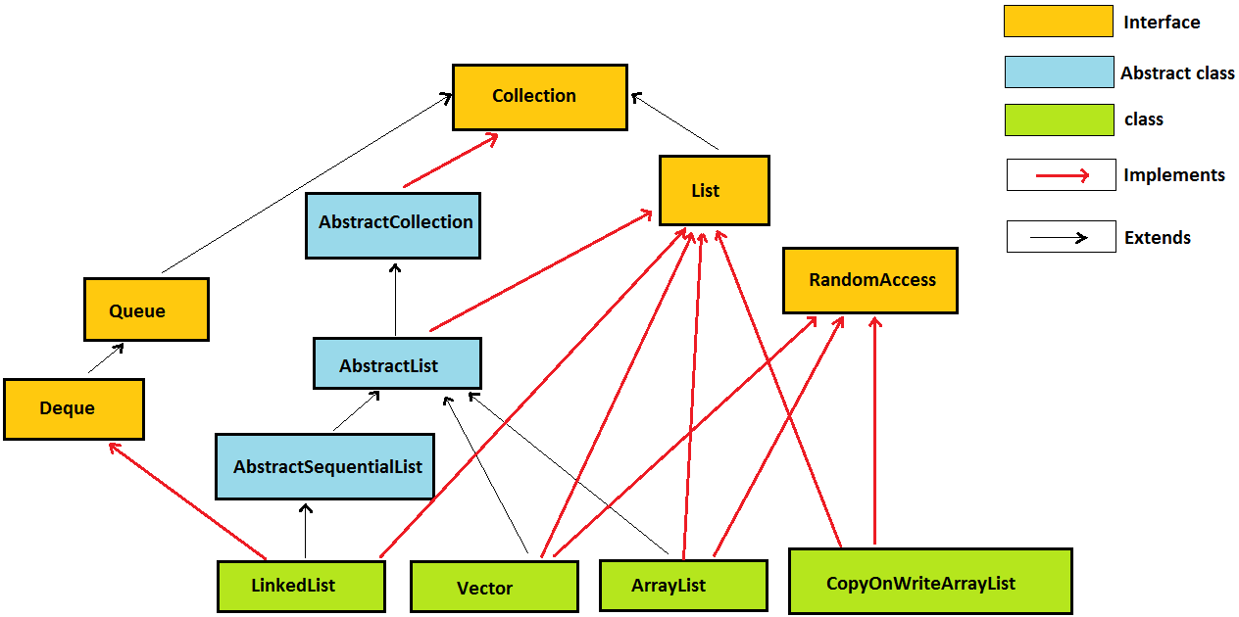
Core classes and interfaces in java.util.Set hierarchy:
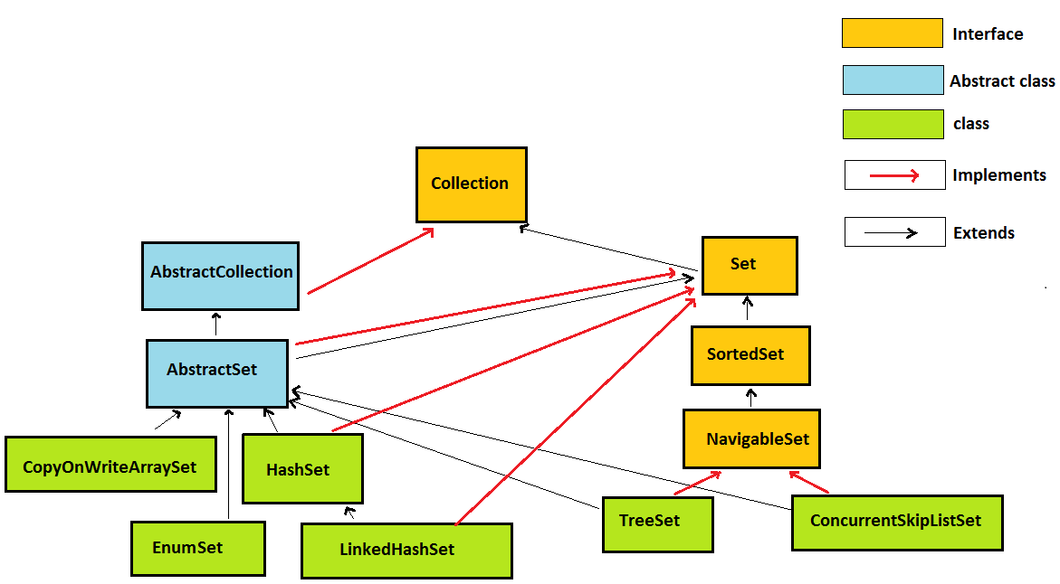
Core classes and interfaces in java.util.Map hierarchy:
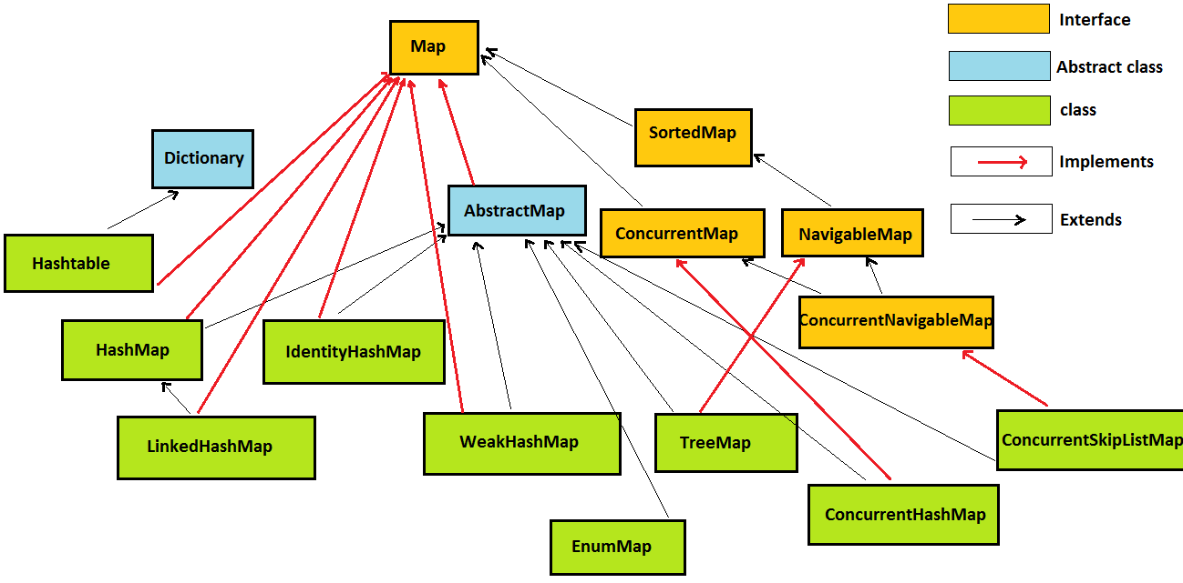

ConcurrentHashMap:
http://javahungry.blogspot.com/2015/02/how-concurrenthashmap-works-in-java-internal-implementation.html

3. BlockingQueue
BlockingQueue is also one of better known collection class in Java 5. BlockingQueue makes it easy to implement producer-consumer design pattern by providing inbuilt blocking support for put() and take() method. put() method will block if Queue is full while take() method will block if Queue is empty. Java 5 API provides two concrete implementation of BlockingQueue in form of ArrayBlockingQueue and LinkedBlockingQueue, both of them implement FIFO ordering of element. ArrayBlockingQueue is backed by Array and its bounded in nature while LinkedBlockingQueue is optionally bounded. Consider using BlockingQueue to solve producer Consumer problem in Java instead of writing your won wait-notify code. Java 5 also provides PriorityBlockingQueue, another implementation of BlockingQueue which is ordered on priority and useful if you want to process elements on order other than FIFO.

Iterator of ConcurrentHashMap are fail-safe iterators which doesn't throw ConcurrencModificationException thus eliminates another requirement of locking during iteration which result in further scalability and performance.

public interface Comparator<T> {
int compare(T object1, T object2);
}

Collections.sort(list, comparator);

Java Collections

Java Collections Tutorial
The Java Collections API's provide Java developers with a set of classes and interfaces that makes it easier to handle collections of objects. In a sense Collection's works a bit like arrays, except their size can change dynamically, and they have more advanced behaviour than arrays.

Java Collections - Overview
In order to understand and use the Java Collections API effectively it is useful to have an overview of the interfaces it contains. So, that is what I will provide here.
There are two "groups" of interfaces: Collection's and Map's.
Here is a graphical overview of the Collection interface hierarchy:
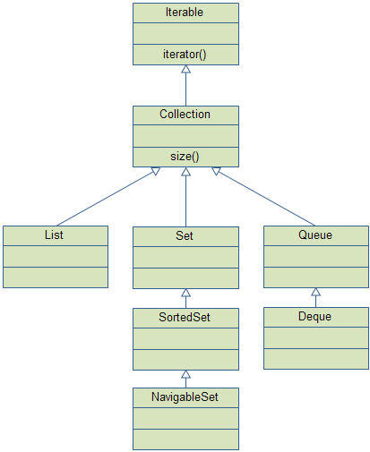
And here is a graphical overview of the Map interface hierarchy:
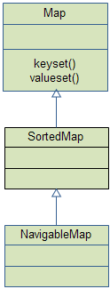

Java Collections - Iterable
The Iterable interface (java.lang.Iterable) is one of the root interfaces of the Java collection classes. The Collection interface extends Iterable, so all subtypes of Collection also implement the Iterable interface.
A class that implements the Iterable can be used with the new for-loop. Here is such an example:
List list = new ArrayList();

for(Object o : list){
//do something o;
}
The Iterable interface has only one method:
public interface Iterable<T> {
public Iterator<T> iterator();
}

Java Generics - Implementing the Iterable Interface
It is possible to use your own collection type classes with the new for-loop. To do so, your class must implement the java.lang.Iterable<E> interface.
Here is a very basic example (VVVI):
public class MyCollection<E> implements Iterable<E>{

public Iterator<E> iterator() {
return new MyIterator<E>();
}
}
And here is the corresponding implementation skeleton of the MyIterator class:
public class MyIterator <T> implements Iterator<T> {

public boolean hasNext() {

//implement...
}

public T next() {
//implement...;
}

public void remove() {
//implement... if supported.
}
}
Here is how to use the MyCollection generified, and with the new for-loop:
public static void main(String[] args) {
MyCollection<String> stringCollection = new MyCollection<String>();

for(String string : stringCollection){

}
}

Java Collections - Collection
The Collection interface (java.util.Collection) is one of the root interfaces of the Java collection classes. Though you do not instantiate a Collection directly, but rather a subtype of Collection, you may often treat these subtypes uniformly as a Collection. In this text you will see how.

Collection Subtypes
The following interfaces (collection types) extends the Collection interface:
- List
- Set
- SortedSet
- NavigableSet
- Queue
- Deque
Java does not come with a usable implementation of the Collection interface, so you will have to use one of the listed subtypes. The Collection interface just defines a set of methods (behaviour) that each of these Collection subtypes share.
Here is a method that operates on a Collection:
public class MyCollectionUtil{

public static void doSomething(Collection collection) {

Iterator iterator = collection.iterator();
while(iterator.hasNext()){
Object object = iterator.next();

//do something to object here...
}
}
}
And here are a few ways to call this method with different Collection subtypes:
Set set = new HashSet();
List list = new ArrayList();

MyCollectionUtil.doSomething(set);
MyCollectionUtil.doSomething(list);

Adding and Removing Elements
Regardless of what Collection subtype you are using there are a few standard methods to add and remove elements from a Collection. Adding and removing single elements is done like this:
String anElement = "an element";
Collection collection = new HashSet();

boolean didCollectionChange = collection.add(anElement);
boolean wasElementRemoved = collection.remove(anElement);
add() adds the given element to the collection, and returns true if the Collection changed as a result of calling the add() method. A Set for instance may not have changed. If the Set already contained that element, it is not added again. On the other hand, if you called add() on a List and the List already contained that element, the element would then exist twice in the List.
remove() removes the given element and returns true if the removed element was present in the Collection, and was removed. If the element was not present, the remove() method returns false.
You can also add and remove collections of objects. Here are a few examples:
Set aSet = ... // get Set with elements from somewhere
List aList = ... // get List with elements from somewhere

Collection collection = new HashSet();

collection.addAll(aSet); //returns boolean too, but ignored here.
collection.addAll(aList); //returns boolean too, but ignored here.

collection.removeAll(aList); //returns boolean too...
collection.retainAll(aSet); //returns boolean too...
addAll() adds all elements found in the Collection passed as parameter to the method. The Collection object itself is not added. Only its elements. If you had called add() with the Collection as parameter instead, the Collection object itself would have been added, not its elements.
Exactly how thet addAll() method behaves depends on the Collection subtype. Some Collection subtypes allows the same element to be added more than once, and others don't.
removeAll() removes all elements found the Collection passed as parameter to the method. If the Collection parameter contains any elements not found the target collection, these are just ignored.
retainAll() does the opposite of removeAll(). Instead of removing all the elements found in the parameter Collection, it keeps all these elements, and removes all other elements. Keep in mind, that only if the elements were already contained in the target collection, are they retained. Any new elements found in the parameter Collection which are not in the target collection, are not automatically added. They are just ignored.

Checking if a Collection Contains a Certain Element
The Collection interface has two methods to check if a Collection contains one or more certain elements. These are the contains() and containsAll() methods. They are illustrated here:
Collection collection = new HashSet();
boolean containsElement = collection.contains("an element");

Collection elements = new HashSet();
boolean containsAll = collection.containsAll(elements);
contains() returns true if the collection contains the element, and false if not.
containsAll() returns true if the collection contains all the elements in the parameter collection, and false if not.

Collection Size
You can check the size of a collection using the size() method. By "size" is meant the number of elements in the collection. Here is an example:
int numberOfElements = collection.size();

Java Collections - Generic Collections
It is possible to generify the various Collection and Map types and subtypes in the Java collection API.
The Collection interface can be generified like this:
Collection<String> stringCollection = new HashSet<String>();
This stringCollection can now only contain String instances. If you try to add anything else, or cast the elements in the collection to any other type than String, the compiler will complain.

for(String stringElement : stringCollection) {
//do something with each stringElement
}
You can do the same thing with List's, Set's etc.

Java Collections - List
The java.util.List interface is a subtype of the java.util.Collection interface. It represents an ordered list of objects, meaning you can access the elements of a List in a specific order, and by an index too. You can also add the same element more than once to a List.

List Implementations
Being a Collection subtype all methods in the Collection interface are also available in the List interface.
Since List is an interface you need to instantiate a concrete implementation of the interface in order to use it. You can choose between the following List implementations in the Java Collections API:
- java.util.ArrayList
- java.util.LinkedList
- java.util.Vector
- java.util.Stack
There are also List implementations in the java.util.concurrent package, but I will leave the concurrency utilities out of this tutorial.
Here are a few examples of how to create a List instance:
List listA = new ArrayList();
List listB = new LinkedList();
List listC = new Vector();
List listD = new Stack();

Adding and Accessing Elements
To add elements to a List you call its add() method. This method is inherited from the Collection interface. Here are a few examples:
List listA = new ArrayList();

listA.add("element 1");
listA.add("element 2");
listA.add("element 3");

listA.add(0, "element 0");
The first three add() calls add a String instance to the end of the list. The last add() call adds a String at index 0, meaning at the beginning of the list.

Removing Elements
You can remove elements in two ways:
- remove(Object element)
- remove(int index)
remove(Object element) removes that element in the list, if it is present. All subsequent elements in the list are then moved up in the list. Their index thus decreases by 1.
remove(int index) removes the element at the given index. All subsequent elements in the list are then moved up in the list. Their index thus decreases by 1.

Generic Lists
By default you can put any Object into a List, but from Java 5, Java Generics makes it possible to limit the types of object you can insert into a List. Here is an example:
List<MyObject> list = new ArrayList<MyObject>();
This list can now only have MyObject instances inserted into it. You can then access and iterate its elements without casting them. Here is how it looks:
MyObject myObject = list.get(0);

for(MyObject anObject : list){
//do someting to anObject...
}

Java Collections - Set
The java.util.Set interface is a subtype of the java.util.Collection interface. It represents set of objects, meaning each element can only exists once in a Set.

Set Implementations
Being a Collection subtype all methods in the Collection interface are also available in the Set interface. Since Set is an interface you need to instantiate a concrete implementation of the interface in order to use it. You can choose between the following Set implementations in the Java Collections API:
- java.util.EnumSet
- java.util.HashSet
- java.util.LinkedHashSet
- java.util.TreeSet
Each of these Set implementations behaves a little differently with respect to the order of the elements when iterating the Set, and the time (big O notation) it takes to insert and access elements in the sets.
HashSet is backed by a HashMap. It makes no guarantees about the sequence of the elements when you iterate them.
LinkedHashSet differs from HashSet by guaranteeing that the order of the elements during iteration is the same as the order they were inserted into the LinkedHashSet. Reinserting an element that is already in the LinkedHashSet does not change this order.
TreeSet also guarantees the order of the elements when iterated, but the order is the sorting order of the elements. In other words, the order in which the elements would be sorted if you used a Collections.sort() on a List or array containing these elements. This order is determined either by their natural order (if they implement Comparable), or by a specific Comparator implementation.
There are also Set implementations in the java.util.concurrent package, but I will leave the concurrency utilities out of this tutorial.
Here are a few examples of how to create a Set instance:
Set setA = new EnumSet();
Set setB = new HashSet();
Set setC = new LinkedHashSet();
Set setD = new TreeSet();

Adding and Accessing Elements
To add elements to a Set you call its add() method. This method is inherited from the Collection interface.

Removing Elements
You remove elements by calling the remove(Object o) method. There is no way to remove an object based on index in a Set, since the order of the elements depends on the Set implementation.

Generic Sets
Set<MyObject> set = new HashSet<MyObject>();

Java Collections - SortedSet
The java.util.SortedSet interface is a subtype of the java.util.Set interface. It behaves like a normal set with the exception that the elements are sorted internally. This means that when you iterate the elements of a SortedSet the elements are returned in the sorted order.
The order of the sorting is either the natural sorting order of the elements (if they implement java.lang.Comparable), or the order determined by a Comparator that you can give to the SortedSet.
By default the elements are iterated in ascending order. But it is also possible to iterate the elements in descending order using the method TreeSet.descendingIterator().
The Java Collections API only has one implementation of the SortedSet interface - the java.util.TreeSet class.
The java.util.concurrent package also has an implementation of this interface, but I will leave the concurrency utilities out of this trail.
Here are two examples of how to create a SortedSet:
SortedSet setA = new TreeSet();

Comparator comparator = new MyComparator();
SortedSet setB = new TreeSet(comparator);

Java Collection - NavigableSet
The java.util.NavigableSet interface is a subtype of the java.util.SortedSet interface. It behaves like a SortedSet with the exception you have navigation methods available in addition to the sorting mechanisms of the SortedSet.
In Java 6 there is only one implementation of the NavigableSet interface in the java.util package: java.util.TreeSet.
There is an implementation in the java.util.concurrent package but that is outside the scope of this trail.
Here is a list of the topics covered in this text:
- descendingIterator() and descendingSet()
- headSet(), tailSet() and subSet()
- ceiling(), floor(), higher() and lower()
- pollFirst() and pollLast()

descendingIterator() and descendingSet()
The first interesting navigation methods are the descendingIterator() and descendingSet() methods.
The descendingSet() method returns a NavigableSet in which the order of the elements is reversed compared to this one. The returned "view" is backed by the original NavigableSet, so changes to the descending set are also reflected in the original set.
Here is a simple example:
NavigableSet reverse = original.descendingSet();
The descendingIterator() method allows you to iterate the elements of the NavigableSet (which is also a SortedSet) in reverse order, without changing the order of the elements internally.
Iterator reverse = original.descendingIterator();

headSet(), tailSet() and subSet()
The headSet() method returns a view of the original NavigableSet which only contains elements that are "less than" the given element. Here is an example:
NavigableSet original = new TreeSet();
original.add("1");
original.add("2");
original.add("3");

//this headset will contain "1" and "2"
SortedSet headset = original.headSet("3");

//this headset will contain "1", "2", and "3" because "inclusive"=true
NavigableSet headset = original.headSet("3", true);
The tailSet() method works the same way, except it returns all elements that are higher than the given parameter element.
The subSet() allows you to pass two parameters demarcating the boundaries of the view set to return. The elements matching the first boundary is included, where as elements matching the last boundary are not. Here is an example:
NavigableSet original = new TreeSet();
original.add("1");
original.add("2");
original.add("3");
original.add("4");
original.add("5");

//this subset will contain "2" and "3"
SortedSet subset = original.subSet("2", "4");

//this subset will contain "2", "3" and "4" because
// fromInclusive=true, and toInclusive=true
NavigableSet subset = original.subSet("2", true, "4", true);

ceiling(), floor(), higher(), and lower()
The ceiling() method returns the least (smallest) element in this set that is greater than or equal to the element passed as parameter to the ceiling() method.
The higher() method returns the least (smallest) element in this set that is greater than (not equal too) the element passed as parameter to the higher() method.

pollFirst() and pollLast()
The pollFirst() method returns and removes the "first" element in the NavigableSet or null if the set is empty. The pollLast() returns and removes the "last" element in the set or null if the set is empty. "First" means smallest element according to the sort order of the set. "Last" means largest according to teh element sorting order of the set.

Java Collections - Map
The java.util.Map interface represents a mapping between a key and a value. The Map interface is not a subtype of the Collection interface. Therefore it behaves a bit different from the rest of the collection types.

Map Implementations
Since Map is an interface you need to instantiate a concrete implementation of the interface in order to use it. You can choose between the following Map implementations in the Java Collections API:
- java.util.HashMap
- java.util.Hashtable
- java.util.EnumMap
- java.util.IdentityHashMap
- java.util.LinkedHashMap
- java.util.Properties
- java.util.TreeMap
- java.util.WeakHashMap
In my experience, the most commonly used Map implementations are HashMap and TreeMap.
Each of these Map implementations behaves a little differently with respect to the order of the elements when iterating the Map, and the time (big O notation) it takes to insert and access elements in the maps.
HashMap maps a key and a value. It does not guarantee any order of the elements stored internally in the map.
TreeMap also maps a key and a value. Furthermore it guarantees the order in which keys or values are iterated - which is the sort order of the keys or values. Check out the JavaDoc for more details.
Here are a few examples of how to create a Map instance:
Map mapA = new HashMap();
Map mapB = new TreeMap();

Adding and Accessing Elements
To add elements to a Map you call its put() method. Here are a few examples:
Map mapA = new HashMap();

mapA.put("key1", "element 1");
mapA.put("key2", "element 2");
mapA.put("key3", "element 3");
The three put() calls maps a string value to a string key. You can then obtain the value using the key. To do that you use the get() method like this:
String element1 = (String) mapA.get("key1");
You can iterate either the keys or the values of a Map. Here is how you do that:
// key iterator
Iterator iterator = mapA.keySet().iterator();

// value iterator
Iterator iterator = mapA.values();
Most often you iterate the keys of the Map and then get the corresponding values during the iteration. Here is how it looks:
Iterator iterator = mapA.keySet().iterator();
while(iterator.hasNext(){
Object key = iterator.next();
Object value = mapA.get(key);
}

//access via new for-loop
for(Object key : mapA.keySet()) {
Object value = mapA.get(key);
}

Removing Elements
You remove elements by calling the remove(Object key) method. You thus remove the (key, value) pair matching the key.

Generic Maps
By default you can put any Object into a Map, but from Java 5, Java Generics makes it possible to limit the types of object you can use for both keys and values in a Map. Here is an example:
Map<String, MyObject> map = new HashMap<String, MyObject>();

Java Collections - SortedMap
The java.util.SortedMap interface is a subtype of the java.util.Map interface, with the addition that the elements stored in the map are sorted internally.
The order of the sorting is either the natural sorting order of the elements (if they implement java.lang.Comparable), or the order determined by a Comparator that you can give to the SortedSet.
By default the elements are iterated in ascending order, starting with the "smallest" and moving towards the "largest". But it is also possible to iterate the elements in descending order using the method TreeMap.descendingKeySet().
The Java Collections API only has one implementation of the SortedMap interface - the java.util.TreeMap class.
The java.util.concurrent package also has an implementation of this interface, but I will leave the concurrency utilities out of this trail.
Here are two examples of how to create a SortedMap:
SortedMap mapA = new TreeMap();

Comparator comparator = new MyComparator();
SortedMap mapB = new TreeMap(comparator);

Java Collections - NavigableMap
The java.util.NavigableMap interface is a subtype of the java.util.SortedMap interface. It has a few extensions to the SortedSet which makes it possible to navigate the map. I will take a closer look at these navigation methods in this text.
The java.util package only has one implementation of the NavigableMap interface: java.util.TreeMap. There is an implementation in the java.util.concurrent package but that is outside the scope of this trail.
Here is a list of the topics covered in this text:
- descendingKeySet() and descendingMap()
- headMap(), tailMap() and subMap()
- ceilingKey(), floorKey(), higherKey() and lowerKey()
- ceilingEntry(), floorEntry(), higherEntry() and lowerEntry()
- pollFirstEntry() and pollLastEntry()

descendingKeySet() and descendingMap()
The descendingKeySet() method returns a NavigableSet in which the order of the elements is reversed compared to the original key set. The returned "view" is backed by the original NavigableSet key set, so changes to the descending set are also reflected in the original set. However, you should not remove elements directly from the key set. Use the Map.remove() method instead.
Here is a simple example:
NavigableSet reverse = map.descendingKeySet();
The descendingMap() method returns a NavigableMap which is a view of the original Map. The order of the elements in this view map is reverse of the order of the original map. Being a view of the original map, any changes to this view is also reflected in the original map.
Here is a simple example:
NavigableMap descending = map.descendingMap();

celingEntry(), floorEntry(), higherEntry(), lowerEntry()
The NavigableMap also has methods to get the entry for a given key, rather than the key itself. These methods behave like the ceilingKey() etc. methods, except they return an Map.Entry instead of the key object itself.
A Map.Entry maps a single key to a single value.

pollFirstEntry() and pollLastEntry()
The pollFirstEntry() method returns and removes the "first" entry (key + value) in the NavigableMap or null if the map is empty. The pollLastEntry() returns and removes the "last" element in the map or null if the map is empty. "First" means smallest element according to the sort order of the keys. "Last" means largest key according to the element sorting order of the map.

Java Collections - Queue
The java.util.Queue interface is a subtype of the java.util.Collection interface. It represents an ordered list of objects just like a List, but its intended use is slightly different. A queue is designed to have elements inserted at the end of the queue, and elements removed from the beginning of the queue. Just like a queue in a supermarket.

Queue Implementations
Being a Collection subtype all methods in the Collection interface are also available in the Queue interface.
Since Queue is an interface you need to instantiate a concrete implementation of the interface in order to use it. You can choose between the following Queue implementations in the Java Collections API:
- java.util.LinkedList
- java.util.PriorityQueue
LinkedList is a pretty standard queue implementation.
PriorityQueue stores its elements internally according to their natural order (if they implement Comparable), or according to a Comparator passed to the PriorityQueue.
There are also Queue implementations in the java.util.concurrent package, but I will leave the concurrency utilities out of this tutorial.
Here are a few examples of how to create a Queue instance:
Queue queueA = new LinkedList();
Queue queueB = new PriorityQueue();

Adding and Accessing Elements
To add elements to a Queue you call its add() method. This method is inherited from the Collection interface. Here are a few examples:
Queue queueA = new LinkedList();

queueA.add("element 1");
queueA.add("element 2");
queueA.add("element 3");
The order in which the elements added to the Queue are stored internally, depends on the implementation. The same is true for the order in which elements are retrieved from the queue. You should consult the JavaDoc's for more information about the specific Queue implementations.
You can peek at the element at the head of the queue without taking the element out of the queue. This is done via the element() method. Here is how that looks:
Object firstElement = queueA.element();
To take the first element out of the queue, you use the remove() method which is described later. To remove elements from a queue, you call the remove() method. This method removes the element at the head of the queue.
Here is a remove example();
Object firstElement = queueA.remove();

Generic Queue
Queue<MyObject> queue = new LinkedList<MyObject>();

Java Collections - Deque
The java.util.Deque interface is a subtype of the java.util.Queue interface. It represents a queue where you can insert and remove elements from both ends of the queue. Thus, "Deque" is short for "Double Ended Queue" and is pronounced "deck", like a deck of cards.

Deque Implementations
Being a Queue subtype all methods in the Queue and Collection interfaces are also available in the Deque interface.
Since Deque is an interface you need to instantiate a concrete implementation of the interface in order to use it. You can choose between the following Deque implementations in the Java Collections API:
- java.util.ArrayDeque
- java.util.LinkedList
LinkedList is a pretty standard deque / queue implementation.
ArrayDeque stores its elements internally in an array. If the number of elements exceeds the space in the array, a new array is allocated, and all elements moved over. In other words, the ArrayDeque grows as needed, even if it stores its elements in an array.
There are also Queue implementations in the java.util.concurrent package, but I will leave the concurrency utilities out of this tutorial.
Here are a few examples of how to create a Deque instance:
Deque dequeA = new LinkedList();
Deque dequeB = new ArrayDeque();

Adding and Accessing Elements
To add elements to the tail of a Deque you call its add() method. You can also use the addFirst() and addLast() methods, which add elements to the head and tail of the deque.
Deque dequeA = new LinkedList();

dequeA.add ("element 1"); //add element at tail
dequeA.addFirst("element 2"); //add element at head
dequeA.addLast ("element 3"); //add element at tail
The order in which the elements added to the Deque are stored internally, depends on the implementation. The two implementations mentioned earlier both store the elements in the order (first or last) in which they are inserted.
You can peek at the element at the head of the queue without taking the element out of the queue. This is done via the element() method. You can also use the getFirst and getLast() methods, which return the first and last element in the Deque. Here is how that looks:
Object firstElement = dequeA.element();
Object firstElement = dequeA.getFirst();
Object lastElement = dequeA.getLast();

Removing Elements
To remove elements from a deque, you call the remove(), removeFirst() and removeLast methods. Here are a few examples:
Object firstElement = dequeA.remove();
Object firstElement = dequeA.removeFirst();
Object lastElement = dequeA.removeLast();

Generic Deque
Deque<MyObject> deque = new LinkedList<MyObject>();

Java Collections - Stack
A Stack is a data structure where you add elements to the "top" of the stack, and also remove elements from the top again.
Here is a Stack usage example:
Stack stack = new Stack();

stack.push("1");
stack.push("2");
stack.push("3");

//look at top object ("3"), without taking it off the stack.
Object objTop = stack.peek();

Object obj3 = stack.pop(); //the string "3" is at the top of the stack.
Object obj2 = stack.pop(); //the string "2" is at the top of the stack.
Object obj1 = stack.pop(); //the string "1" is at the top of the stack.

Searching the Stack
You can search for an object on the stack to get it's index, using the search() method. The object's equals() method is called on every object on the Stack to determine if the searched-for object is present on the Stack. The index you get is the index from the top of the Stack, meaning the top element on the Stack has index 1.
Here is how you search a Stack for an object:
Stack stack = new Stack();

stack.push("1");
stack.push("2");
stack.push("3");

int index = stack.search("3"); //index = 3

Java Collections - hashCode() and equals()
The methods hashCode() and equals() play a distinct role in the objects you insert into Java collections. The specific contract rules of these two methods are best described in the JavaDoc. Here I will just tell you what role they play. What they are used for, so you know why their implementations are important.

equals()
equals() is used in most collections to determine if a collection contains a given element. For instance:
List list = new ArrayList();
list.add("123");

boolean contains123 = list.contains("123");
The ArrayList iterates all its elements and execute "123".equals(element) to determine if the element is equal to the parameter object "123". It is the String.equals() implementation that determines if two strings are equal.
The equals() method is also used when removing elements. For instance:
List list = new ArrayList();
list.add("123");

boolean removed = list.remove("123");
The ArrayList again iterates all its elements and execute "123".equals(element) to determine if the element is equal to the parameter object "123". The first element it finds that is equal to the given parameter "123" is removed.
As you can see, a proper implementation of .equals() is essential for your own classes to work well with the Java Collection classes. So how do you implement equals() "properly"?
So, when are two objects equal? That depends on your application, the classes, and what you are trying to do. For instance, let's say you are loading and processing Employee objects stored in a database. Here is a simple example of such an Employee class:
public class Employee {
protected long employeeId;
protected String firstName;
protected String lastName;
}
You could decide that two Employee objects are equal to each other if just their employeeId's are equal. Or, you could decide that all fields must be equal - both employeeId, firstName and lastName. Here are two example implementation of equals() matching these criterias:
public class Employee {
...
public boolean equals(Object o){
if(o == null) return false;
if(!(o instanceof) Employee) return false;

Employee other = (Employee) o;
return this.employeeId == other.employeeId;
}
}
public class Employee {
...
public boolean equals(Object o){
if(o == null) return false;
if(!(o instanceof) Employee) return false;

Employee other = (Employee) o;
if(this.employeeId != other.employeeId) return false;
if(! this.firstName.equals(other.firstName)) return false;
if(! this.lastName.equals(other.lastName)) return false;

return true;
}
}

hashCode()
The hashCode() method of objects is used when you insert them into a HashTable, HashMap or HashSet.
When inserting an object into a hashtable you use a key. The hash code of this key is calculated, and used to determine where to store the object internally. When you need to lookup an object in a hashtable you also use a key. The hash code of this key is calculated and used to determine where to search for the object.
The hash code only points to a certain "area" (or list, bucket etc) internally. Since different key objects could potentially have the same hash code, the hash code itself is no guarantee that the right key is found. The hashtable then iterates this area (all keys with the same hash code) and uses the key's equals() method to find the right key. Once the right key is found, the object stored for that key is returned.
So, as you can see, a combination of the hashCode() and equals() methods are used when storing and when looking up objects in a hashtable.
Here are two rules that are good to know about implementing the hashCode() method in your own classes, if the hashtables in the Java Collections API are to work correctly:
- If object1 and object2 are equal according to their equals() method, they must also have the same hash code.
- If object1 and object2 have the same hash code, they do NOT have to be equal too.

Java Collections - Sorting
You can sort List collections using the java.util.Collections.sort() method. You can sort these two types of List's.
- List
- LinkedList

Sorting Objects by their Natural Order
To sort a List you do this:
List list = new ArrayList();

//add elements to the list

Collections.sort(list);
When sorting a list like this the elements are ordered according to their "natural order". For objects to have a natural order they must implement the interface java.lang.Comparable. In other words, the objects must be comparable to determine their order. Here is how the Comparable interface looks:
public interface Comparable<T> {
int compareTo(T o);
}
The compareTo() method should compare this object to another object, return an int value. Here are the rules for that int value:
- Return a negative value if this object is smaller than the other object
- Return 0 (zero) if this object is equal to the other object.
- Return a positive value if this object is larger than the other object.

Sorting Objects Using a Comparator
Sometimes you may want to sort a list according to another order than their natural order. Perhaps the objects you are sorting do not even have a natural order. In that case you can use a Comparator instead. Here is how you sort a list using a Comparator:
List list = new ArrayList();

//add elements to the list

Comparator comparator = new SomeComparator();

Collections.sort(list, comparator);
Notice how the Collections.sort() method now takes a java.util.Comparator as parameter in addition to the List. This Comparator compares the elements in the list two by two. Here is how the Comparator interface looks:
public interface Comparator<T> {
int compare(T object1, T object2);
}

Concurrent Collections
The java.util.concurrent package includes a number of additions to the Java Collections Framework. These are most easily categorized by the collection interfaces provided:
- BlockingQueue defines a first-in-first-out data structure that blocks or times out when you attempt to add to a full queue, or retrieve from an empty queue.
- ConcurrentMap is a subinterface of java.util.Map that defines useful atomic operations. These operations remove or replace a key-value pair only if the key is present, or add a key-value pair only if the key is absent. Making these operations atomic helps avoid synchronization. The standard general-purpose implementation of ConcurrentMap is ConcurrentHashMap, which is a concurrent analog of HashMap.
- ConcurrentNavigableMap is a subinterface of ConcurrentMap that supports approximate matches. The standard general-purpose implementation of ConcurrentNavigableMap is ConcurrentSkipListMap, which is a concurrent analog of TreeMap.
All of these concurrent collections help avoid Memory Consistency Errors by defining a happens-before relationship between an operation that adds an object to the collection with subsequent operations that access or remove that object.

Top 5 Concurrent Collections from JDK 5 and 6 Java Programmer Should Know
1. ConcurrentHashMap
ConcurrentHashMap is undoubtedly most popular collection class introduced in Java 5 and most of us are already using it. ConcurrentHashMap provides a concurrent alternative of Hashtable or Synchronized Map classes with aim to support higher level of concurrency by implementing fined grained locking (default 1/16th). Multiple reader can access the Map concurrently while a portion of Map gets locked for write operation depends upon concurrency level of Map. ConcurrentHashMap provides better scalability than there synchronized counter part. Iterator of ConcurrentHashMap are fail-safe iterators which doesn't throw ConcurrencModificationException thus eliminates another requirement of locking during iteration which result in further scalability and performance.

2. CopyOnWriteArrayList and CopyOnWriteArraySet
CopyOnWriteArrayList is a concurrent alternative of synchronized List. CopyOnWriteArrayList provides better concurrency than synchronized List by allowing multiple concurrent reader and replacing the whole list on write operation. Yes, write operation is costly on CopyOnWriteArrayList but it performs better when there are multiple reader and requirement of iteration is more than writing. Since CopyOnWriteArrayList Iterator also don't throw ConcurrencModificationException it eliminates need to lock the collection during iteration. Remember both ConcurrentHashMap and CopyOnWriteArrayList doesn't provides same level of locking as Synchronized Collection and achieves thread-safety by their locking and mutability strategy. So they perform better if requirements suits there nature. Similarly, CopyOnWriteArraySet is a concurrent replacement to Synchronized Set.

3. BlockingQueue
BlockingQueue is also one of better known collection class in Java 5. BlockingQueue makes it easy to implement producer-consumer design pattern by providing inbuilt blocking support for put() and take() method. put() method will block if Queue is full while take() method will block if Queue is empty. Java 5 API provides two concrete implementation of BlockingQueue in form of ArrayBlockingQueue and LinkedBlockingQueue, both of them implement FIFO ordering of element. ArrayBlockingQueue is backed by Array and its bounded in nature while LinkedBlockingQueue is optionally bounded. Consider using BlockingQueue to solve producer Consumer problem in Java instead of writing your won wait-notify code. Java 5 also provides PriorityBlockingQueue, another implementation of BlockingQueue which is ordered on priority and useful if you want to process elements on order other than FIFO.

4. Deque and BlockingDeque
Deque interface is added in Java 6 and it extends Queue interface to support insertion and removal from both end of Queue referred as head and tail. Java6 also provides concurrent implementation of Deque like ArrayDeque and LinkedBlockingDeque. Deque Can be used efficiently to increase parallelism in program by allowing set of worker thread to help each other by taking some of work load from other thread by utilizing Deque double end consumption property. So if all Thread has there own set of task Queue and they are consuming from head; helper thread can also share some work load via consumption from tail.

5. ConcurrentSkipListMap and ConcurrentSkipListSet
Just like ConcurrentHashMap provides a concurrent alternative of synchronized HashMap. ConcurrentSkipListMap and ConcurrentSkipListSet provide concurrent alternative for synchronized version of SortedMap and SortedSet. For example instead of using TreeMap or TreeSet wrapped inside synchronized Collection, You can consider using ConcurrentSkipListMap or ConcurrentSkipListSet from java.util.concurrent package. They also implement NavigableMap and NavigableSet to add additional navigation method.

Difference between LinkedList vs ArrayList in Java
LinkedList and ArrayList both implement List Interface but how they work internally is where the differences lies. Main difference between ArrayList and LinkedList is that ArrayList is implemented using re sizable array while LinkedList is implemented using doubly LinkedList.

LinkedList vs ArrayList in Java
All the differences between LinkedList and ArrayList has there root on difference between Array and LinkedList data-structure. If you are familiar with Array and LinkedList data structure you will most likely derive following differences between them:

1) Since Array is an index based data-structure searching or getting element from Array with index is pretty fast. Array provides O(1) performance for get(index) method but remove is costly in ArrayList as you need to rearrange all elements. On the Other hand LinkedList doesn't provide Random or index based access and you need to iterate over linked list to retrieve any element which is of order O(n).

2) Insertions are easy and fast in LinkedList as compared to ArrayList because there is no risk of resizing array
and copying content to new array if array gets full which makes adding into ArrayList of O(n) in worst case, while adding is O(1) operation in LinkedList in Java. ArrayList also needs to update its index if you insert something anywhere except at the end of array.
3) Removal is like insertions better in LinkedList than ArrayList.
4) LinkedList has more memory overhead than ArrayList because in ArrayList each index only holds actual object (data) but in case of LinkedList each node holds both data and address of next and previous node.

When to use LinkedList and ArrayList in Java
As I said LinkedList is not as popular as ArrayList but still there are situation where a LinkedList is better choice than ArrayList in Java. Use LinkedList in Java if:
1) Your application can live without Random access. Because if you need nth element in LinkedList you need to first traverse up to nth element O(n) and than you get data from that node.
2) Your application is more insertion and deletion driver and you insert or remove more than retrieval. Since insertion or removal doesn't involve resizing its much faster than ArrayList.

Use ArrayList in Java for all there situation where you need a non-synchronized index based access. ArrayList is fast and easy to use.

fail-safe vs fail-fast Iterator in Java

Difference between fail-fast Iterator vs fail-safe Iterator in Java

fail-fast Iterators in Java
As name suggest fail-fast Iterators fail as soon as they realized that structure of Collection has been changed since iteration has begun. Structural changes means adding, removing or updating any element from collection while one thread is Iterating over that collection. fail-fast behavior is implemented by keeping a modification count and if iteration thread realizes the change in modification count it throws ConcurrentModificationException.
Java doc says this is not a guaranteed behavior instead its done of "best effort basis", So application programming can not rely on this behavior. Also since multiple threads are involved while updating and checking modification count and this check is done without synchronization, there is a chance that Iteration thread still sees a stale value and might not be able to detect any change done by parallel threads. Iterators returned by most of JDK1.4 collection are fail-fast including Vector, ArrayList, HashSet, LinkedList etc.

fail-safe Iterator in java
Contrary to fail-fast Iterator, fail-safe iterator doesn't throw any Exception if Collection is modified structurally
while one thread is Iterating over it because they work on clone of Collection instead of original collection and that’s why they are called as fail-safe iterator. Iterator of CopyOnWriteArrayList is an example of fail-safe Iterator also iterator written by ConcurrentHashMap keySet is also fail-safe iterator and never throw ConcurrentModificationException in Java.

What is the difference between Enumeration and Iterator ?
Between Enumeration and Iterator, Enumeration is older and its there from JDK1.0 while iterator was introduced later. Iterator can be used with Java arraylist, java hashmap keyset and with any other collection classes.
Another similarity between Iterator and Enumeration in Java is that functionality of Enumeration interface is duplicated by the Iterator interface.
Only major difference between Enumeration and iterator is Iterator has a remove() method while Enumeration doesn't. Enumeration acts as Read-only interface, because it has the methods only to traverse and fetch the objects, where as by using Iterator we can manipulate the objects like adding and removing the objects from collection e.g. Arraylist.
Also Iterator is more secure and safe as compared to Enumeration because it does not allow other thread to modify the collection object while some thread is iterating over it and throws ConcurrentModificationException. This is by far most important fact for me for deciding between Iterator vs Enumeration in Java.

In Summary both Enumeration and Iterator will give successive elements, but Iterator is new and improved version where method names are shorter, and has new method called remove. Here is a short comparison:

Enumeration
hasMoreElement()
nextElement()
N/A

Iterator
hasNext()
next()
remove()

So Enumeration is used when ever we want to make Collection objects as Read-only.
Difference between ArrayList and Vector in Java
Java 5 adds another implementation of List interface which is similar to Vector and ArrayList but provides better concurrency access than Vector, its called CopyOnWriteArrayList. By the way this is the third article on discussing about Collection interview question,
Before seeing differences between Vector and ArrayList, let's see some similarities between these two and why we can use ArrayList in place of Vector on certain scenario.

1) Vector and ArrayList are index based and backed up by an array internally.
2) Both ArrayList and Vector maintains the insertion order of element. Means you can assume that you will get the object in the order you have inserted if you iterate over ArrayList or Vector.
3) Both Iterator and ListIterator returned by ArrayList and Vector are fail-fast.
4) ArrayList and Vector also allows null and duplicates.

Vector vs ArrayList in Java
Now let's see some key difference between Vector and ArrayList in Java, this will decide when is the right time to use Vector over ArrayList and vice-versa. Differences are based upon properties like synchronization, thread safety, speed, performance , navigation and Iteration over List etc.

1) Synchronization and thread-safety
First and foremost difference between Vector and ArrayList is that Vector is synchronized and ArrayList is not, what it means is that all the method which structurally modifies Vector e.g. add () or remove () are synchronized which makes it thread-safe and allows it to be used safely in a multi-threaded and concurrent environment. On the other hand ArrayList methods are not synchronized thus not suitable for use in multi-threaded environment.

2) Speed and Performance
ArrayList is way faster than Vector. Since Vector is synchronized and thread-safe it pays price of synchronization which makes it little slow. On the other hand ArrayList is not synchronized and fast which makes it obvious choice in a single-threaded access environment. You can also use ArrayList in a multi-threaded environment if multiple threads are only reading values from ArrayList or you can create read only ArrayList as well.

3) Capacity
Whenever Vector crossed the threshold specified it increases itself by value specified in capacityIncrement field while you can increase size of ArrayList by calling ensureCapacity () method.

4) Enumeration and Iterator
Vector can return enumeration of items it hold by calling elements () method which is not fail-fast as opposed to Iterator and ListIterator returned by ArrayList.
After considering these points about both Vector and ArrayList , my conclusion is use ArrayList wherever possible and avoids use of Vector until you have no choice. Think for CopyOnWriteArrayList over Vector, if you have multiple readers and few writers because it can provide thread-safety without impacting performance too much.

=VVI=> Instead of a map wide lock, ConcurrentHashMap maintains a list of 16 locks by default ( number of locks equal to the initial capacity , which is by default 16) each of which is used to lock on a single bucket of the Map.This indicates that 16 threads (number of threads equal to the concurrency level , which is by default 16) can modify the collection at the same time , given ,each thread works on different bucket. So unlike hashtable, we perform any sort of operation (update ,delete ,read ,create) without locking on entire map in ConcurrentHashMap.
The concurrency level of the ConcurrentHashMap should be set equal to the expected number of threads going to concurrently update the ConcurrentHashMap.

